**GAME CONCEPT 1**

* At the start of each turn, a target will spawn along the player’s respective side of the screen.
* A projectile-like object will spawn from the bottom of the screen and will automatically move up and down from their spawn point.
* The player must tap the screen to fire the projectile towards the target when the two are aligned with each other.
* The number of points the player gets depends on how close the projectile lands to the centre of the target.
* Landing the projectile completely off the target could either decrease their score, or simply award zero points.
* A player’s turn ends after their projectile is fired and has hit or missed their target. The star indicates whose turn it is.
* After a set number of turns, the player with the highest score wins.

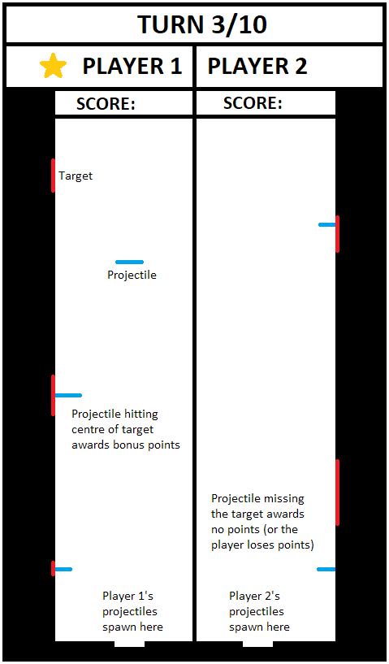

(Difficulty could be increased by gradually raising the speeds of the targets and projectiles. In addition, a short timer could be added which resets on each player’s turn. This could help add tension within gameplay and force players to react faster.)

**GAME CONCEPT 2**

* Similar play style to Concept 1.
* The game begins with a number of coloured Target Points along the bottom of the screen. These points travel horizontally across the screen and will loop back to the left side.
* A block of a certain colour will appear at the top of the screen. The player must tap to send the block falling down when it and its corresponding Target Point are aligned with each other.
* The number of points the player gets depends on how close the block is to the centre of the correct Target Point.
* Landing the projectile completely off the target could either decrease their score, or simply award zero points.
* Multiple blocks can be stacked upon each other to award bonus points.
* A player’s turn ends after their block has landed. The star indicates whose turn it is.
* 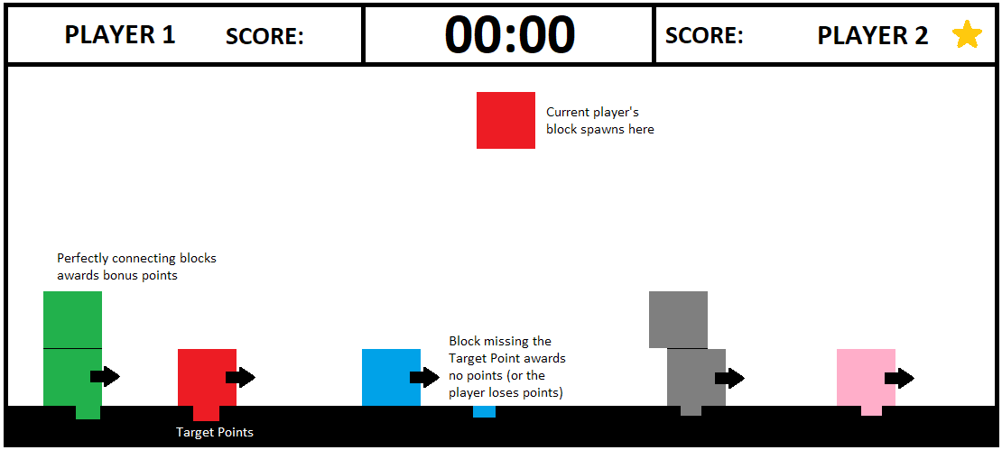When the time expires, the player with the highest score wins.

(Difficulty could change depending on the number of blocks, their size and movement speed, as well as the speed of the Target Points and falling blocks.)